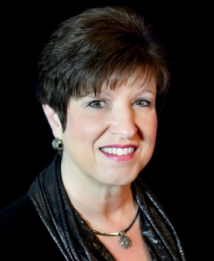

Kay Horner
Executive Director
Pentecostal Charismatic Churches of North America, Awakening America Alliance & The Helper Connection

Kay has served in a variety of ministry roles including executive director of New Hope Pregnancy Care Center, associate and interim pastor of Peerless Road Church, administrator for Voice of Salvation Ministries, and Christian education minister providing insight segments for the World Impact television program. She was blessed to serve as ministry projects coordinator for the Center for Spiritual Renewal, the spearhead organization for the 2006 Azusa Street Centennial. Currently, Kay is executive Director for the Pentecostal Charismatic Churches of North America, Awakening America Alliance, and Helper Connection, ministries that train, resource, and encourage men and women ministers throughout the kingdom of God. She has authored The Christmas Dance and Today’s Church and is a contributing author in Praying with Jesus, Cry Out to the Lord, 31 Days of Prayer for My Nation, Cherished Moments, and More Cherished Moments. Her articles have been published in SpiritLed Woman, Charisma News Daily, Prayer Connect Magazine, White Wing Messenger, and several national ministry blogs. Kay serves as secretary for the board of directors of The Table Coalition/U.S. Lausanne Committee, is engaged with the National Prayer Committee, Jesus Covenant Prayer Partners, and other national prayer ministries. She is founder and chairperson of the Women in Ministry Commission with the Pentecostal Charismatic Churches of North America. She completed her BS in Christian Ministries/Bible at Lee University and enjoys ministering in ecumenical leadership summits and regional ladies’ conferences both nationally and abroad. Kay is married to Perry Horner, a retired graphic designer for their denomination’s international offices. He is currently a funeral assistant serving families during their time of bereavement and enjoys providing practical assistance and home repairs for retired ministers and widows. Their daughter Emily, her husband Kirk, and granddaughter Lillian reside in Cleveland, Tennessee. Their son Ben lives nearby in Chattanooga.

To schedule an interview or speaking engagement with Kay, contact her via
P. O. Box 3986, Cleveland, TN 37320 ■ Phone: 423.310.2885 ■ Email: khorner@awakeningamerica.us

